**The Barley Stripe Rust Screening Trial (BSRST)**

Chris Massman, Tanya Filichkin, Scott Fisk, Laura Helgerson, and Patrick Hayes

BarleyWorld. Oregon State University. Corvallis, Oregon, USA.

***Germplasm:***

**The BSRST, in addition to screening current and potential varieties, is a useful monitoring system: by the inclusion of long-term checks, changes in pathogen virulence that affect adult plant resistance can be detected. The BSRST is organized by OSU (with support from the USDA-ARS) via solicitation of accessions from public breeding programs in California, Idaho, Montana, Oregon, Utah, and Washington. Winter, facultative, and spring growth habit accessions are phenotyped for adult plant resistance at Corvallis, Oregon. It is possible to test germplasm of the three growth habits in fall-planted experiments due to the unique and balancing climatic conditions in Corvallis. Temperatures at Corvallis are rarely low enough to cause injury to spring growth habit types but they are low enough to ensure sufficient vernalization of winter growth habit types.**

***Stripe rust (and other diseases) - assessment procedures:***

**Barley stripe rust (BSR, incited by *Puccinia striiformis* f.sp. *hordei*) is a serious disease of barley throughout the world. In the US, it is endemic in cooler, wetter areas of the west coast. However, there are an increasing number of reports of stripe rust on barley from other parts of the US and the world. Therefore, continued progress in screening for resistance in current, new, and potential varieties is warranted.**

Disease susceptibility was measured using a severity score in Corvallis, OR. Severity was scored as percentage of leaf area affected with the disease on a plot basis. A Randomized Complete Block Design with two replications and 46 total barley inbred lines was used. Natural infection was supplemented with artificial inoculation of susceptible borders surrounding the experiment. Scoring for BSR was conducted on two dates, one week apart. Notes on other diseases were recorded as they were present in this trial. In this data set, we also provide information on scald (incited by *Rhynchosporium commune*).

***General conclusions:***

* The presence of lines with high severity BSR and/or scald infections point to the continued value of the BSRST. Plant pathogens are an ever-evolving threat and development of resistant cultivars requires breeders be in the know about trends in germplasm susceptibility.
* Significant genotypic differences for both BSR and scald severity were identified in this trial with high heritability.
* Scald severity had a significant negative correlation with heading date, as noted in previous iterations of the BSRST. This is a confounding factor in the search for genetic resistance to scald and indicates later heading lines may escape infection.

***Data:***

Please see <https://barleyworld.org/barley-stripe-rust-bsr>

***Fundings:***

Support provided by USDA-ARS-NACA 58 2050 6 005 for stripe rust and stem rust research.

***This report:***

In this report, we provide information and interpretation for the BSRST in 2023 at the Corvallis, Oregon environment.

***Tables and Figures:***

**Phenotypic frequency distributions for Julian heading date**

Heading date ranged from 119 to 137 days after January 1st with a trial mean of 127 days. Broad sense heritability was .98 on an entry-mean basis.

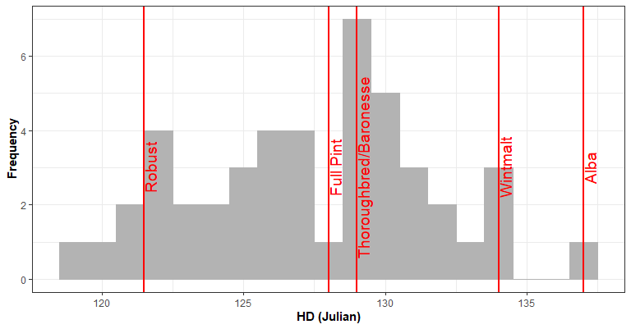

**Phenotypic frequency distributions for BSR severity on May 30th, 2023**

BSR Severity ranged from 0.0% to 17.5% on May 30th with a trial mean of 3.0% severity. Broad sense heritability was .89 on an entry-mean basis.

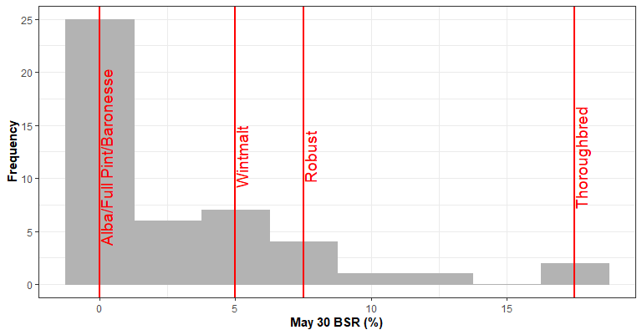

**Phenotypic frequency distributions for BSR severity on June 6th, 2023**

BSR Severity ranged from 0.0% to 30.0% on June 6th with a trial mean of 5.8% severity. Broad sense heritability was .93 on an entry-mean basis.

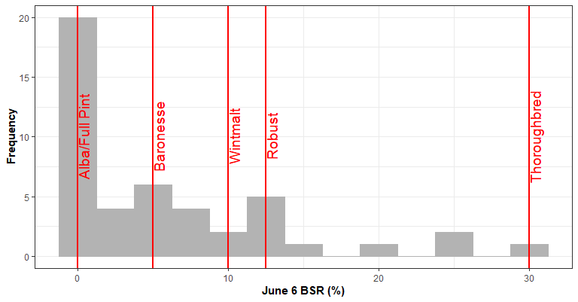

**Phenotypic frequency distributions for scald severity at the adult plant stage**

Scald Severity ranged from 0% to 77.5% at the adult plant stage with a trial mean of 23.2% severity. Broad sense heritability was .83 on an entry-mean basis.

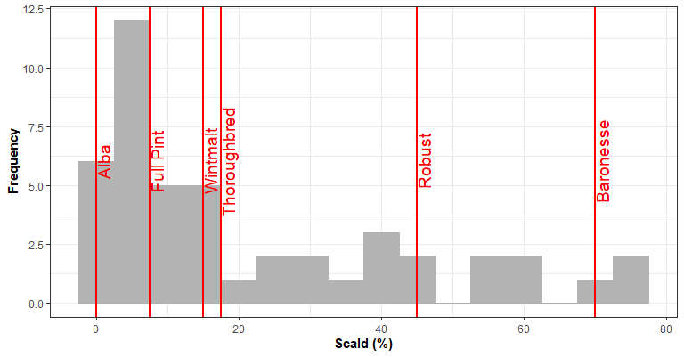

**Phenotypic correlations**

There were high and significant correlations between BSR ratings across the two dates. There was a moderate and significant correlation between scald severity and heading date, which has been documented in previous years of the BSRST trial. Heading date had no significant correlation with BSR severity and scald severity had no significant correlation with BSR severity.

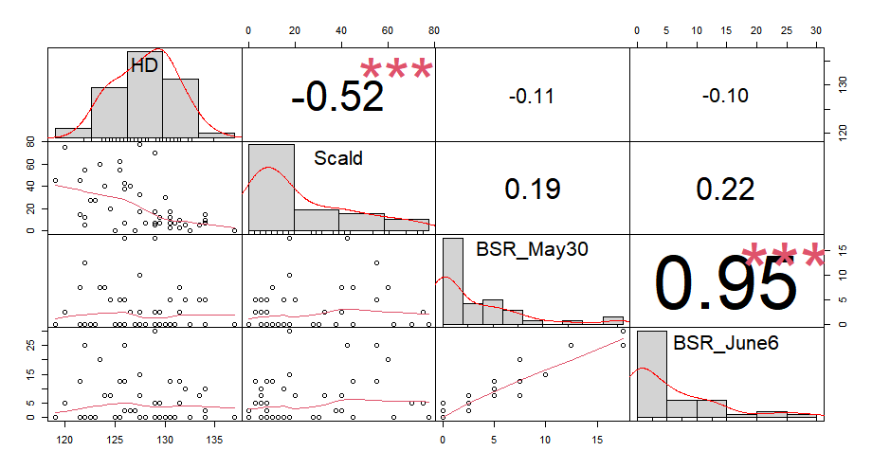

**Genotypic means with groups determined by a Tukey test for heading date, scald severity at the adult plant stage, and BSR severity at each assessment date.**

|  |  |  |  |  |  |  |  |  |
| --- | --- | --- | --- | --- | --- | --- | --- | --- |
| **Line** | **HD** | **HD Group** | **Scald** | **Scald Group** | **BSR (May30)** | **BSR (May 30) Group** | **BSR (June 6)** | **BSR (June 6) Group** |
| 13ARS537-19 | 124.5 | KLMNOPQ | 20.0 | BCDEF | 5.0 | BCD | 7.5 | DEF |
| 15ARS602-1 | 131.5 | BCDE | 10.0 | CDEF | 7.5 | BCD | 12.5 | CDE |
| 15ARS604-2 | 129.5 | DEFGHI | 7.5 | DEF | 0.0 | D | 5.0 | DEF |
| 15ARS607-1 | 130.5 | BCDEFG | 17.5 | BCDEF | 0.0 | D | 0.0 | F |
| 16ARS622-248 | 130.5 | BCDEFG | 7.5 | DEF | 0.0 | D | 0.0 | F |
| 16ARS627-037 | 127.0 | GHIJKLM | 0.0 | F | 0.0 | D | 2.5 | EF |
| 16ARS634-2 | 130.5 | BCDEFG | 12.5 | CDEF | 0.0 | D | 0.0 | F |
| 16ARS638-28 | 126.0 | IJKLMNO | 7.5 | DEF | 5.0 | BCD | 12.5 | CDE |
| Alba | 137.0 | A | 0.0 | F | 0.0 | D | 0.0 | F |
| Baronesse | 129.0 | DEFGHIJ | 70.0 | AB | 0.0 | D | 5.0 | DEF |
| Butta 12 | 126.5 | HIJKLMN | 40.0 | ABCDEF | 2.5 | CD | 2.5 | EF |
| DH141917 | 129.5 | DEFGHI | 12.5 | CDEF | 0.0 | D | 0.0 | F |
| DH150683 | 125.0 | KLMNOPQ | 0.0 | F | 0.0 | D | 0.0 | F |
| DH162310 | 122.0 | PQRS | 12.5 | CDEF | 0.0 | D | 0.0 | F |
| DH170472 | 130.0 | CDEFGH | 30.0 | ABCDEF | 0.0 | D | 0.0 | F |
| DH180670 | 130.5 | BCDEFG | 2.5 | EF | 5.0 | BCD | 12.5 | CDE |
| DH180676 | 129.5 | DEFGHI | 7.5 | DEF | 2.5 | CD | 5.0 | DEF |
| FRANCIN | 127.5 | FGHIJKL | 77.5 | A | 0.0 | D | 0.0 | F |
| Full Pint | 128.0 | EFGHIJK | 7.5 | DEF | 0.0 | D | 0.0 | F |
| Lightning | 131.0 | BCDEF | 7.5 | DEF | 0.0 | D | 0.0 | F |
| MT16F01601 | 123.5 | MNOPQR | 60.0 | ABCD | 7.5 | BCD | 20.0 | ABC |
| MT16M02101 | 122.0 | PQRS | 55.0 | ABCDE | 12.5 | AB | 25.0 | AB |
| MT17M02507 | 126.0 | IJKLMNO | 42.5 | ABCDEF | 17.5 | A | 25.0 | AB |
| MT18M06011 | 120.0 | RS | 75.0 | A | 2.5 | CD | 5.0 | DEF |
| MT21_M094_04 | 121.5 | QRS | 15.0 | CDEF | 0.0 | D | 0.0 | F |
| MT21_M094_05 | 125.5 | JKLMNOP | 55.0 | ABCDE | 5.0 | BCD | 12.5 | CDE |
| MT21_M094_06 | 122.0 | PQRS | 5.0 | EF | 0.0 | D | 0.0 | F |
| MT21_M094_08 | 123.0 | NOPQR | 27.5 | ABCDEF | 0.0 | D | 0.0 | F |
| Robust | 121.5 | QRS | 45.0 | ABCDEF | 7.5 | BCD | 12.5 | CDE |
| TAMALPAIS | 126.0 | IJKLMNO | 37.5 | ABCDEF | 0.0 | D | 2.5 | EF |
| Thoroughbred | 129.0 | DEFGHIJ | 17.5 | BCDEF | 17.5 | A | 30.0 | A |
| Thunder | 127.5 | FGHIJKL | 32.5 | ABCDEF | 2.5 | CD | 7.5 | DEF |
| UC SCHALLER | 124.0 | LMNOPQ | 40.0 | ABCDEF | 7.5 | BCD | 7.5 | DEF |
| UC Tahoe | 125.5 | JKLMNOP | 62.5 | ABC | 0.0 | D | 0.0 | F |
| UC TEHAMA | 122.5 | OPQRS | 27.5 | ABCDEF | 0.0 | D | 0.0 | F |
| UC-Capay | 119.0 | S | 45.0 | ABCDEF | 0.0 | D | 0.0 | F |
| UC-Gallagher | 129.0 | DEFGHIJ | 7.5 | DEF | 0.0 | D | 0.0 | F |
| UT10201 | 132.0 | BCD | 5.0 | EF | 5.0 | BCD | 10.0 | CDEF |
| UTWB10406-9 | 134.0 | AB | 7.5 | DEF | 0.0 | D | 2.5 | EF |
| UTWB11241-4 | 129.0 | DEFGHIJ | 5.0 | EF | 2.5 | CD | 5.0 | DEF |
| UTWB11514-1 | 134.0 | AB | 10.0 | CDEF | 0.0 | D | 0.0 | F |
| UTWB11601-1 | 127.5 | FGHIJKL | 17.5 | BCDEF | 10.0 | ABC | 15.0 | BCD |
| WB11135-1 | 131.5 | BCDE | 2.5 | EF | 2.5 | CD | 5.0 | DEF |
| WB11135-2 | 133.5 | ABC | 5.0 | EF | 5.0 | BCD | 7.5 | DEF |
| WB11434-10 | 132.5 | BCD | 0.0 | F | 0.0 | D | 0.0 | F |
| Wintmalt | 134.0 | AB | 15.0 | CDEF | 5.0 | BCD | 10.0 | CDEF |